**CLIENT**

**API GATEWAY**

***Micro Services***



**Product Management Service**

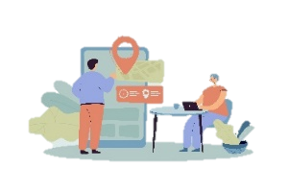

**User Management Service**

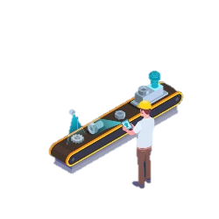

**Manufacturer Management Service**



**Payment Management Service**



**Campaign Management Service**

**User DB**



**Product DB**



**Campaign DB**



**Manufacturer DB**



**Payment DB**

***Client***

***Server***

***Database***